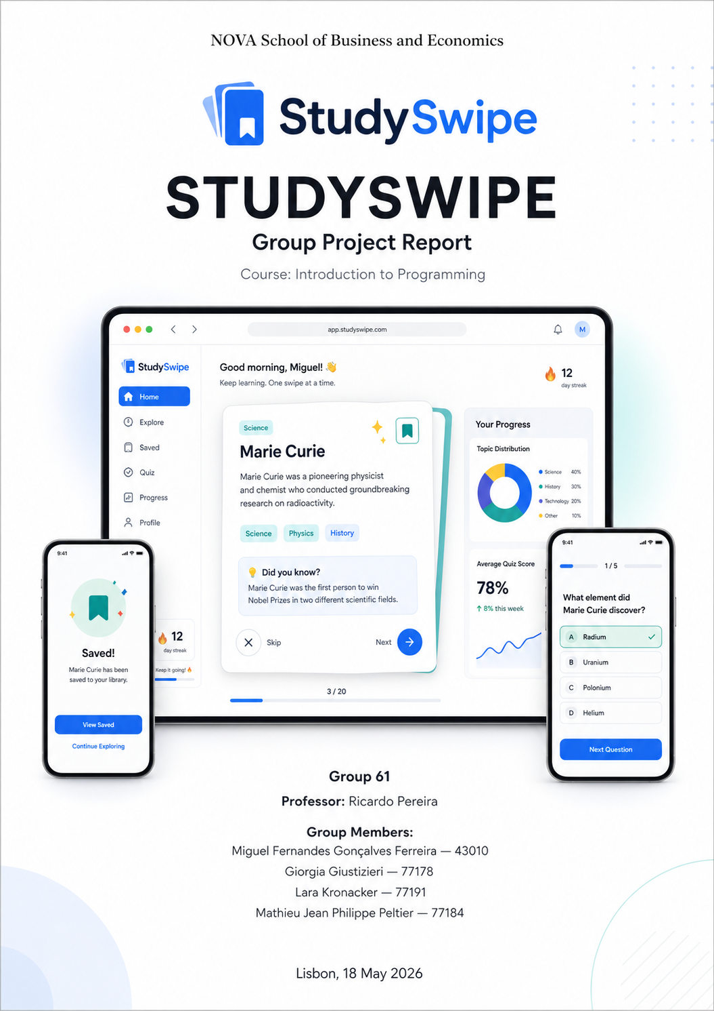

1. Introduction
StudySwipe is a web-based micro-learning application that retrieves content from Wikipedia and presents it as a feed of study cards that users navigate using buttons. Each card contains a short summary of a topic, a set of key facts extracted from the article text, and a multiple-choice quiz question. Users can browse the feed, save topics into named collections, and revisit saved material through a dedicated review mode. An analytics page summarizes activity across the session, showing category distribution, quiz performance, and reading streaks. The project was developed as a single Streamlit web application written in Python. The requests library is used for external API calls, pandas is used for lightweight data processing, and saved topics and quiz history are stored in a local JSON file so that collections survive page reloads and Streamlit reruns.
The concept builds directly on the official Wiki-Tok sample proposal from the course materials, which suggests a TikTok-like feed of Wikipedia summaries, but extends it into a stronger educational product by adding a save-and-review loop, quiz mode, topic filters, and an analytics page. In other words, StudySwipe moves beyond passive short-form browsing and becomes a lightweight study companion for quick learning and revision.
The remainder of this report explains the application’s real-life utility, its main features, its technical architecture, and the ways in which it applies the core programming concepts taught during the course.

2. Real-Life Utility and Motivation
StudySwipe addresses a practical learning problem: long-form information is often valuable, but difficult to consume quickly, especially when users are exploring unfamiliar topics or revising under time pressure. Wikipedia contains a vast quantity of reliable and freely accessible information, but article length and complexity can create friction for casual learners. StudySwipe reduces that friction by converting longer articles into compact cards that present the essential content first and then allow the user to deepen engagement gradually through saved collections and quizzes.
This use case is supported by the scale of the Wikimedia ecosystem. The Wikimedia Foundation’s 2022–2023 annual report states that Wikipedia receives 15 billion views every month, and the Wikimedia Analytics API documentation states that its pageview endpoints provide data for Wikimedia projects starting on 1 July 2015. This means StudySwipe is built on a large, stable, and globally used knowledge base rather than on a small custom dataset.
The application is useful in at least three ways. First, it supports micro-learning, where users want to learn something meaningful in a short time window. Second, it supports revision, because saved topics can be revisited later and paired with quiz questions. Third, it supports discovery, because more popular topics can be surfaced through pageview data instead of being chosen randomly. This combination of learning, revision, and discovery turns StudySwipe into more than a feed reader: it becomes a lightweight educational tool.

3. Core Features: What StudySwipe Does
StudySwipe is organized around five main features. When a user first opens the app, they land on the Feed, a sequence of topic cards drawn from Wikipedia. Each card is assembled from a short plain-text extract retrieved from the MediaWiki REST API, a set of key facts extracted from article text, and a monthly pageview count from the Wikimedia Analytics API that serves as a popularity indicator. Cards are ranked so that topics with higher recent traffic appear earlier in the feed, giving the experience a sense of relevance without forcing the user to search manually. The MediaWiki REST API is explicitly designed to provide access to wiki content and functionality through a RESTful HTTP interface, making it appropriate for this kind of application.
Users move through the feed using buttons such as Prev, Skip, Random, Save, and a Wikipedia link that opens the full source article. This button-based navigation replaced the earlier swipe-style concept and is more consistent with the actual implementation described in the updated report. From any topic card, the user can save the topic into a named collection. Collections are chosen and managed by the user, for example “History Revision” or “Science Picks,” and are accessible from the Saved tab.
Within a collection, users can review cards at their own pace or launch Quiz Mode for that collection. In Quiz Mode, the application presents one multiple-choice question per card. When a Google Gemini API key is available, quiz questions are generated through the Gemini API. Google’s Gemini documentation shows generateContent as the standard content-generation endpoint, which makes it suitable for turning article text into question prompts. When no Gemini key is available, the application falls back to local quiz generation. In that fallback mode, the app creates fill-in-the-blank questions from numbers or years found in the article text, or generates true/false questions by modifying words in the article content. The answer options remain in a fixed order (a, b, c, d) rather than being shuffled. Quiz results are then recorded and later summarized on the Analytics page.
A topic filter in the sidebar allows the user to restrict the feed by category, article length, or minimum popularity threshold. If the filter is changed during a session, the feed updates using already-retrieved data rather than making a new API request. In this way, StudySwipe creates a coherent learning loop — learn → save → quiz → revisit — which gives the product more depth than the baseline Wiki-Tok concept and aligns well with the rubric’s emphasis on problem coverage, feature integration, and user experience.

4. Technical Architecture and Implementation
The application is organized as a single Python file that Streamlit re-executes from top to bottom on every user interaction. Keeping state consistent across those reruns is therefore a central technical challenge, and StudySwipe addresses it by storing mutable state in st.session_state. On the first run, the app initializes the main objects and data structures there. On subsequent runs, it reads from and writes to that same session state instead of rebuilding the feed, saved topics, and quiz progress from scratch. This is a natural fit for a Streamlit application and supports the fast, interactive workflow expected from the product.
The data pipeline for a single topic card begins with get_summary(), which calls the MediaWiki REST API and returns a plain-text extract and thumbnail URL for a requested article. get_page_views() then calls the Wikimedia Analytics API and returns the total view count for that article over the previous thirty days. These retrieved values are combined with key facts extracted from article text inside fetch_and_add_article(), which creates the objects used by the application. This separation of concerns makes the code easier to maintain and also improves resilience: if one API call fails, the others can still succeed, and a card can still be assembled with partial data. The MediaWiki REST API documentation notes that the API can return data in JSON or HTML and is intended for building apps and scripts that access Wikipedia and other Wikimedia projects.
Quiz generation is handled by generate_quizzes_with_ai(). When an AI key is available, the function prompts Gemini to generate article-based quiz questions. When no key is available, the application switches to fallback generation using values already found in the article text, especially numbers and years, or by creating true/false questions from modified statements. This design keeps the application usable even without external AI access. Persistence is handled through a local JSON file rather than a database. When users save or unsave a topic through save_topic() and unsave_topic(), the relevant state is updated and written to disk so that saved collections and quiz history survive a browser refresh. That approach keeps the architecture lightweight and appropriate for a local, single-user study app.

5. Applications of Course Concepts

5.1 Data Structures (Expressions and Data Structures)
Every piece of information the app works with is stored in an explicit data structure chosen to match the shape of the data. Raw API responses arrive as JSON and are parsed into Python dictionaries. A list of topic-card objects represents the current feed in display order. Saved collections are stored as a dictionary that maps collection names to lists of topic identifiers, and quiz history is stored in nested dictionaries so that per-topic accuracy can be tracked efficiently. This directly reflects the first course module’s emphasis on deciding what data is needed and how it should be represented.
The application also uses tuples in several places. Fixed seed article lists and category keyword sets are represented as tuples because they are predefined, ordered, and not intended to change during ordinary use. This is a direct application of the course distinction between mutable and immutable structures.
The core classes used by the app are Topic, TopicMetrics, FactCard, QuizItem, and TopicCard. These classes give clear names and structure to the main entities in the program, making the rest of the code easier to read than if everything were stored in anonymous dictionaries alone.

5.2 Flow Control
The app uses conditional logic throughout to handle realistic cases that arise from user input and external services. When the feed is initialized, the app checks whether relevant topic data is already stored in session state. If it is, the app renders from existing data; if not, it retrieves new content. When a user tries to save a topic, the app checks whether that topic is already present in the chosen collection and skips the append if necessary, preventing duplicates. When quiz generation begins, the application checks whether an AI key is available. If yes, it uses Gemini-based generation; if not, it falls back to local quiz generation.
Loops are equally important. for loops are used to iterate through topic lists, saved collections, and extracted facts. In addition, while loops are used for retrying failed API calls and for collecting enough quiz questions for a session, because the number of retries or valid questions is not always known in advance. This matches the course module’s explanation that while loops are appropriate when repetition should continue until a condition is met.

5.3 Functions
The application is decomposed into small, single-purpose functions that each perform one task and return a value. get_summary() retrieves article summaries, get_page_views() retrieves recent article popularity, fetch_and_add_article() combines retrieved information into the internal article structures, and generate_quizzes_with_ai() creates quiz questions when the Gemini API is available. save_topic() and unsave_topic() manage persistence and collection updates. Keeping these functions focused reduces repetition, makes the code easier to debug, and allows one part of the application to change without forcing a rewrite of the rest. This directly applies the course module’s emphasis on descriptive names, single-purpose functions, and returning values instead of printing them.
Functions are especially important when working with external services. One function handles article retrieval, another retrieves analytics, and another combines those outputs into topic-card objects. By separating these operations, the code becomes easier to test and more robust when one service behaves unexpectedly.

5.4 Classes
The application uses five main classes: Topic, TopicMetrics, FactCard, QuizItem, and TopicCard. These are implemented as ordinary Python classes with constructors using self, not as dataclasses. Together they define the main entities of the program. TopicCard is especially important because it groups the core information needed for display and includes methods such as get_popularity_label(), get_difficulty_label(), and has_quiz(), which allow the rest of the application to query the card cleanly and consistently. This follows the course module’s central lesson that classes are useful when data and behavior belong together.
This object-oriented structure is appropriate because the application repeatedly works with the same kinds of entities: topics, metrics, facts, quizzes, and display cards. Encapsulating them into classes makes the app easier to reason about and helps keep related behavior attached to the objects it belongs to.

6. User Experience and Application Flow
The interface is organized into four tabs accessible from a top navigation bar: Feed, Saved, Quiz, and Analytics. When the app first loads, the Feed tab is active and shows the first card in the ranked topic list. The card occupies the center of the screen and displays the topic title, a thumbnail image where available, the short Wikipedia summary, key facts extracted from article text, and a small popularity badge showing the monthly view count. Below the card, navigation buttons such as Prev, Skip, Random, Save, and a Wikipedia link let the user move through the feed or open the full source article. A dropdown in the sidebar chooses the target collection for saves.
The Saved tab shows all collections as expandable sections. Selecting a collection reveals its cards in a compact list view. A launch-quiz control at the top of each collection starts a focused quiz session for that material. The Quiz tab presents one question at a time with four answer options rendered as buttons in a fixed order. After the user selects an answer, the app shows the correct response and then moves on. The Analytics tab uses bar charts to summarize category distribution and quiz accuracy, alongside summary statistics such as total cards viewed, total saves, and overall quiz performance.

7. Limitations and Possible Improvements
The current version has several known limitations. Topic discovery relies on a fixed seed list of article titles rather than on a fully live trending feed, which means content does not update automatically between sessions unless the seed list is changed. A natural improvement would be to pull seed topics dynamically from a live Wikimedia popularity source so that the feed reflects recent public interest more directly. Quiz generation is also uneven across topics. When a Gemini API key is available, the application can generate more natural quiz questions, but fallback generation based on numbers, years, and true/false modifications can be simpler and less varied. Expanding the fallback logic and improving local question templates would therefore make the quiz experience more consistent. Finally, the current JSON persistence approach is well suited to a single-user local app, but it does not support multi-user access or cross-device synchronization.

8. Conclusion
StudySwipe takes the feed concept suggested in the course’s Wiki-Tok sample and develops it into a fuller micro-learning application. The feed, save-and-review loop, quiz mode, and analytics page work together as one coherent workflow rather than as independent features. Technically, the project applies each of the four course modules in a direct and visible way: data structures model the content and user state, flow control handles filtering and fallback logic, functions keep API communication and transformations modular, and classes give the application’s core entities consistent behavior. The result is a working Streamlit application that is both demonstrably useful and grounded in the programming concepts taught during the course.

9. References

Course documents and uploaded materials
- Introduction to Programming – Course info.
- Introduction to Programming – Group project brief and rubric.
- Introduction to Programming – Museum / Outstanding group projects.
- Introduction to Programming – Wiki-Tok sample project proposal.
- Module 1: Expressions and data structures.
- Module 2: Flow control.
- Module 3: Functions.
- Module 4: Classes.

Official external sources
- MediaWiki REST API documentation.
- Wikimedia Analytics API documentation.
- Google Gemini API documentation.
- Wikimedia Foundation 2022–2023 Annual Report.

